Minister of Healthcare of the Republic of Kazakhstan
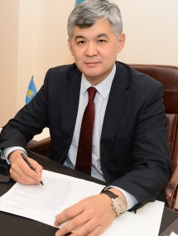

E.A. Birtanov was born on October 18, 1971 in Zhambyl. He graduated from Almaty state medical institute, the University of the State of Arizona, the Russian medical academy of postgraduate education, University clinic Charite (Germany), Turan University, Duke University, Fuqua School of Business (USA), Master's Program of Global Executive MBA. Worked as the resuscitator of hospital of emergency medical service in Almaty, the head of the Republican center for toxicology, the chief toxicologist of the Ministry of Health of the RK, Director of RSE "Institute of Healthcare Development of " of the Ministry of Health of the RK, adviser to the Prime minister of the RK, the Vice Chairman of the Board of JSC 'National Medical Holding", the Vice Minister of Health of the RK, headed JSC National Medical Holding. Since May, 2014 - the Chairman of the Board of the Center for support of public-private partnership projects. Since November 12, 2015 - the Vice Minister of healthcare and social development of the RK. Excellent worker of health care of the Republic of Kazakhstan. Doctor of medical sciences.

